ASEN 2004 ROCKET LAB -- LAUNCH DATA SHEET

Data Recorded by Date / Time of launch

Group # Lab Time MW8 / MW10 / TTh2 (circle one) Launch Attempt #

Dry Mass grams Launch Pad: orange / plain (circle one)
Prop Mass grams Altimeter #
Wet Launch Mass grams Launch Pad Angle deg (from horizon)
Post Flight Mass grams Bottle Pressure psi

Surface Wind - Speed / Direction mph from the
Winds Aloft - Speed / Direction mph from the

Temperature deg F

Distance (d) feet (at impact) Time of Flight (1) = sec
Drift Angle (α) deg (to left or right?) Time of Flight (2) = sec
Time of Flight (3) = sec

Notes:

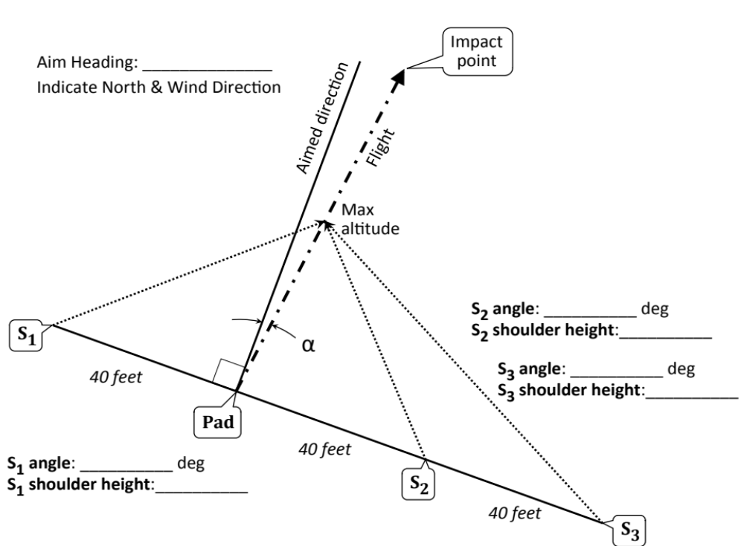

ASEN 2004 ROCKET LAB -- LAUNCH DATA SHEET

Data Recorded by Date / Time of launch

Group # Lab Time MW8 / MW10 / TTh2 (circle one) Launch Attempt #

Dry Mass grams Launch Pad: orange / plain (circle one)
Prop Mass grams Altimeter #
Wet Launch Mass grams Launch Pad Angle deg (from horizon)
Post Flight Mass grams Bottle Pressure psi

Surface Wind - Speed / Direction mph from the
Winds Aloft - Speed / Direction mph from the

Temperature deg F

Distance (d) feet (at impact) Time of Flight (1) = sec
Drift Angle (α) deg (to left or right?) Time of Flight (2) = sec
Time of Flight (3) = sec

Notes:

